Name:………………………………………………..…. Date:………………………………………………………
Fireworks

Every 5th of November tonnes of fireworks are set off in the UK. The tradition arose because nearly 400 years ago, Guy Fawkes and others tried to explode barrels of gunpowder under the House of Commons in the Palace of Westminster where Members of Parliament (MPs) meet. Their aim was to kill King James I and destroy Parliament. After a tip off, King James ordered the cellar to be searched. Guy Fawkes was found laying fuses to gunpowder barrels. He was arrested and taken to the Tower of London, where he was tortured. On 30th January 1606 Guy Fawkes and the others were beheaded for treason, which means 'crime against the country'. When the public heard that the King and Parliament had been threatened but were safe, bonfires were lit in celebration. When a new session of parliament starts, the cellar is searched - this tradition continues today. Our celebration of Guy Fawkes's arrest lights the skies on 5th November.

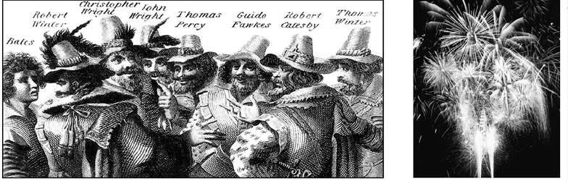
The gunpowder conspirators of 1605  Reproduced with kind permission of akg-images | A modern fireworks display  Reproduced with kind permission of Paul Tierney

What is a firework?
What do you think is the main problem with this method? This experiment helps you find out what a firework is. Make careful observations.

What you need?
- 1 party popper
- 1 sparkler
- Eye protection
- Match / splint to light the sparkler
- Heatproof mat
- Bucket of cold water to dispose of the sparkler.

What you do
- Fire the party popper. Watch what happens. Write down in the table what you see and smell.
- Clear up the mess!
- Light the sparkler, holding it over the heatproof mat. Write down what you see and smell when the sparkler is burning.
- When the sparkler burns out, put the hot metal into the bucket of cold water.

continued on next page


Fireworks
continued from previous page

Safety
Wear eye protection.
Observation table
Firework | What I saw | What I smelt and heard
Party Popper | ……………………………………………………  …………………………………………………….  ……………………………………………………  ……………………………………………………. | ……………………………………………………  …………………………………………………….  ……………………………………………………  …………………………………………………….
Sparkler | ……………………………………………………  …………………………………………………….  ……………………………………………………  ……………………………………………………. | ……………………………………………………  …………………………………………………….  ……………………………………………………  …………………………………………………….

Questions
1. How does a party popper work?
................................................................................................................................................................................................................................................................................................................ ................................................................................................................................................................................................................................................................................................................
2. Where did the solid substance on the sparkler go to?
................................................................................................................................................................................................................................................................................................................ ................................................................................................................................................................................................................................................................................................................ ................................................................................................................................................................................................................................................................................................................
3. What causes the sparks to appear in the air when the sparkler is lit?
................................................................................................................................................................................................................................................................................................................

continued on next page

Fireworks
continued from previous page

4. Write down five observations which are the same for all fireworks.
........................................................................................................................................................ ..........................................................................................................................…………………….………………………………………………………………………………………………………………. ..........................................................................................................................…………………….……………………………………………………………………………………………………………….
Conclusion
Write down one sentence explaining what a firework is.
..................................................................................................................................................................................................................................................................................…………………….………………………………………………………………………………………………………………. ..................................................................................................................................................................................................................................................................................…………………….……………………………………………………………………………………………………………….

